USD Overnight Curve Analysis
- USD overnight curve with Meta OIS , synth deposits / no jumps (AS IS)
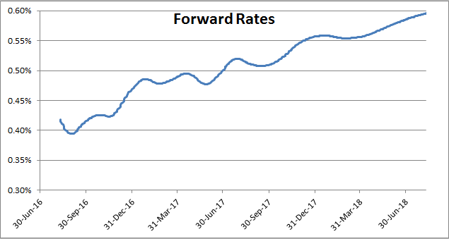

- USD overnight curve with Arithmetic Average Fed Fund OIS (no approx.), with synth deposits / no jumps
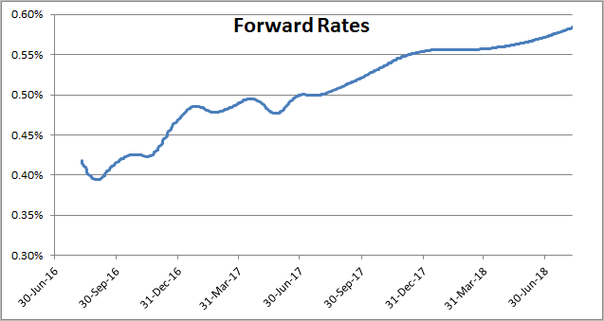
- USD overnight curve with Arithmetic Average Fed Fund OIS with approx. formula, synth deposits / no jumps
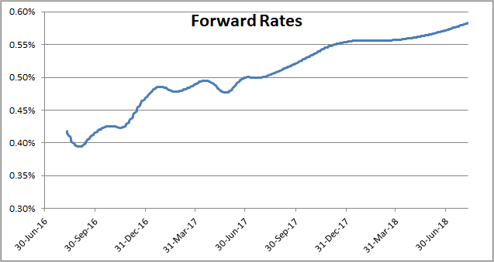

- USD overnight curve with Arithmetic Average Fed Fund OIS with approx. formula, synth deposits and including jumps
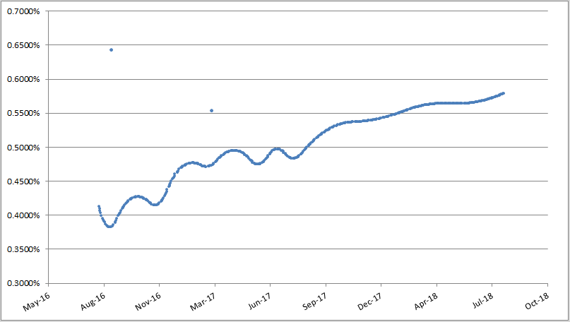
- USD overnight curve with Meta OIS, synth deposits and including jumps (AS IS + Jumps)
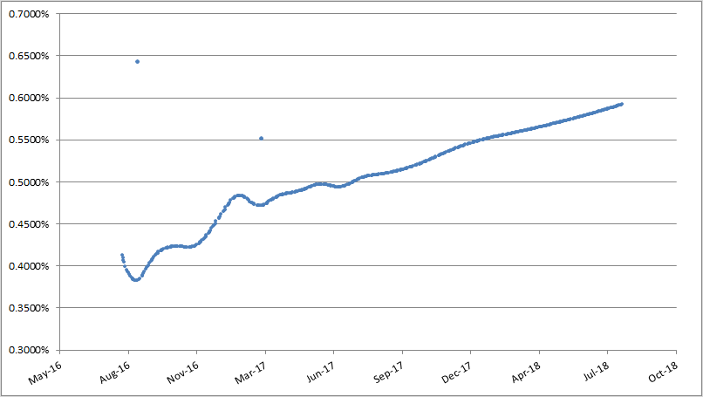

GBP Overnight Curve Analysis
- GBP overnight curve with synth deposits / no jumps (AS IS)
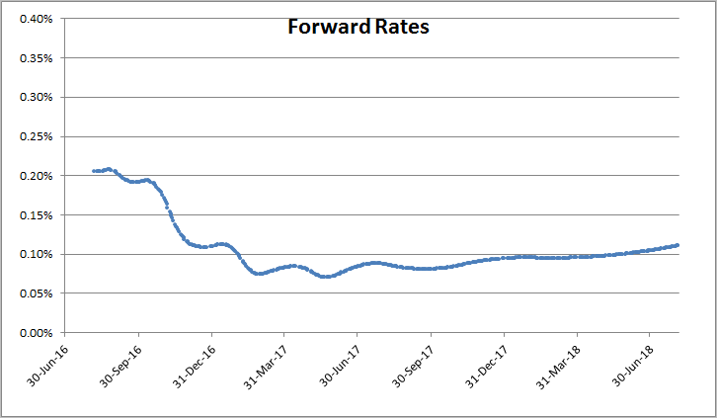
- GBP overnight curve including synth deposits and jumps
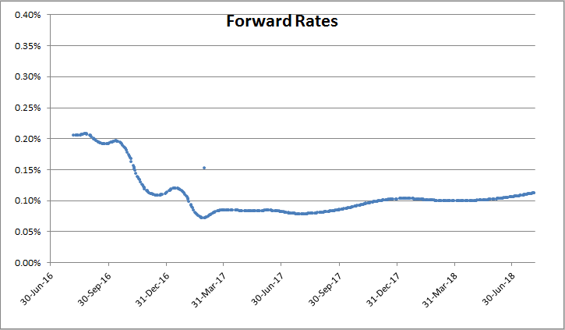
EUR Overnight Curve Analysis
- EUR overnight curve no jumps, with synth deposits and overlapping OIS
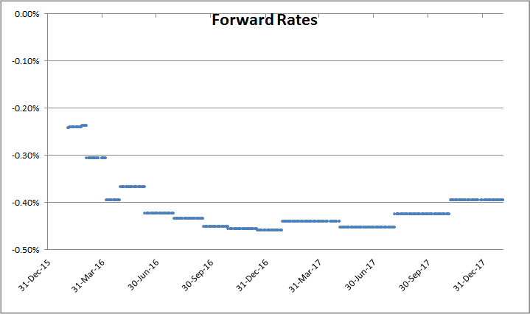
- EUR overnight curve no jumps, with synth deposits and forward Stub
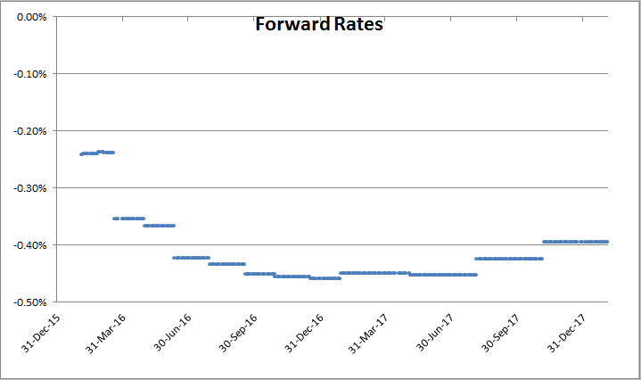
- EUR overnight curve with jumps, synth deposits and forward Stub
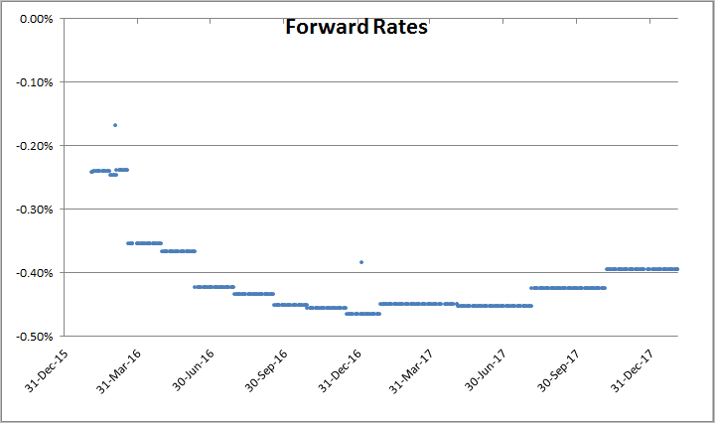

- Repricing errors analysis

